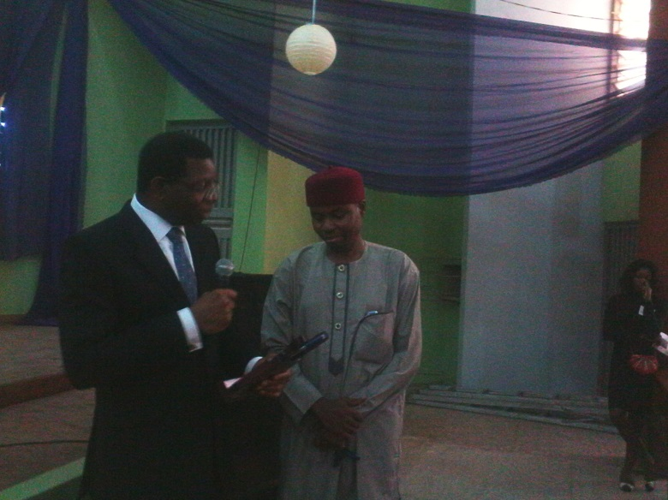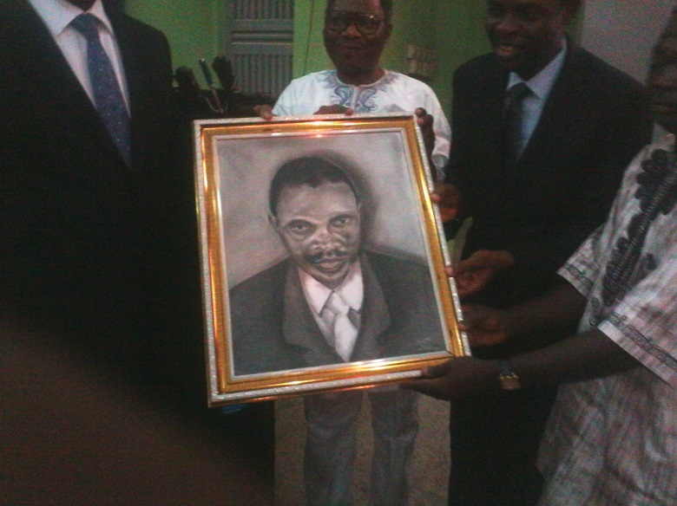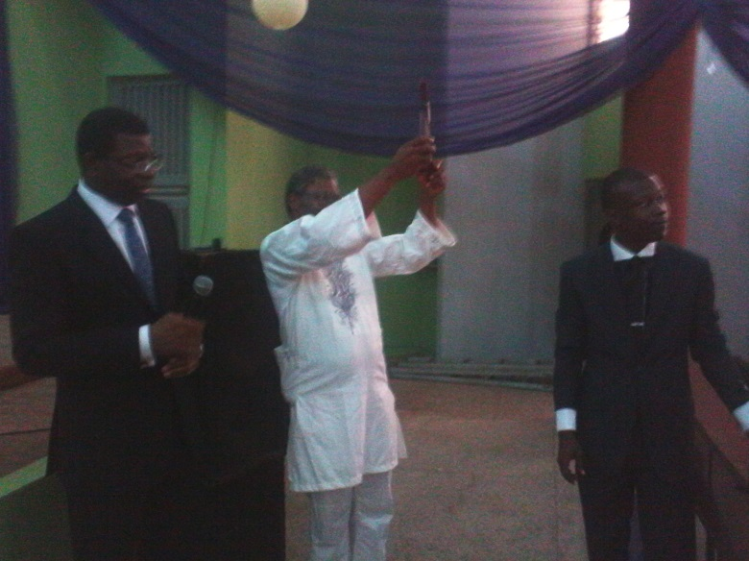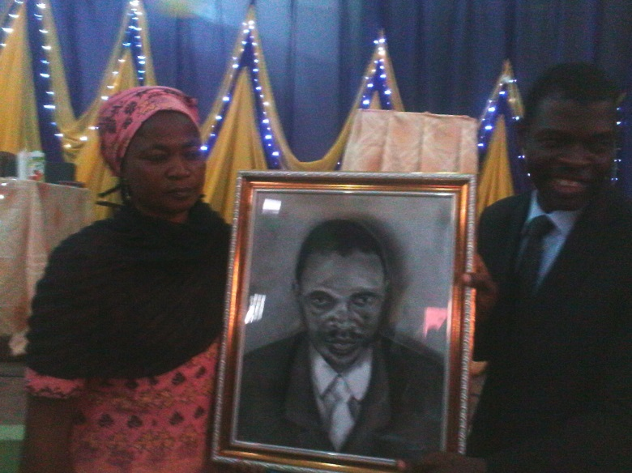**PHOTOS FROM UCJ PROGRAM - 2014 MUSIBAU ADETUNBI FORUM ON CONSTITUTIONALITY AND GOOD GOVERNANCE HELD ON SATURDAY, 2ND OF AUGUST, 2014 AT THE FACULTY OF ARTS LECTURE THEATRE.**